BSEF17A537
QUESTION # 1:

(a)

(b)
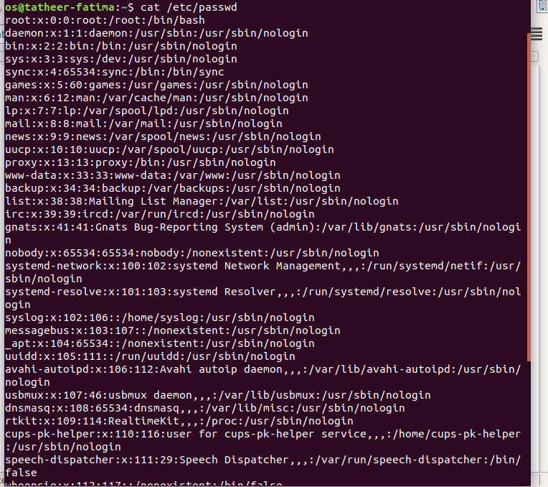

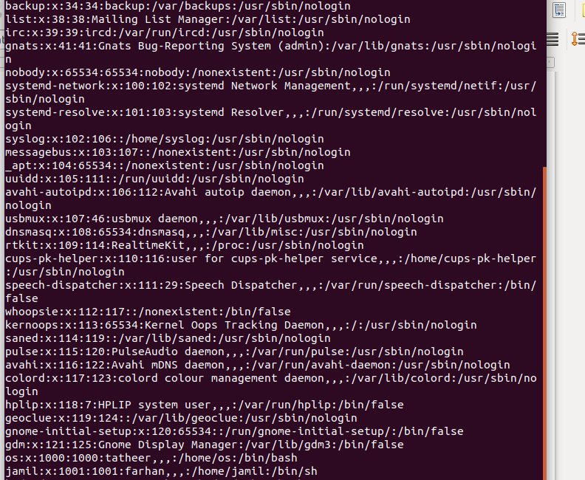
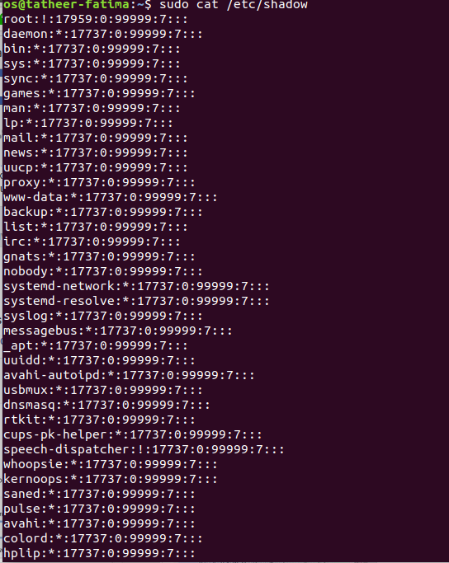

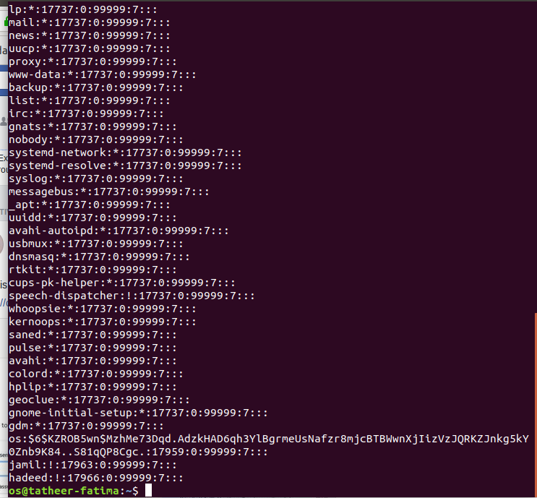

(c) (d)
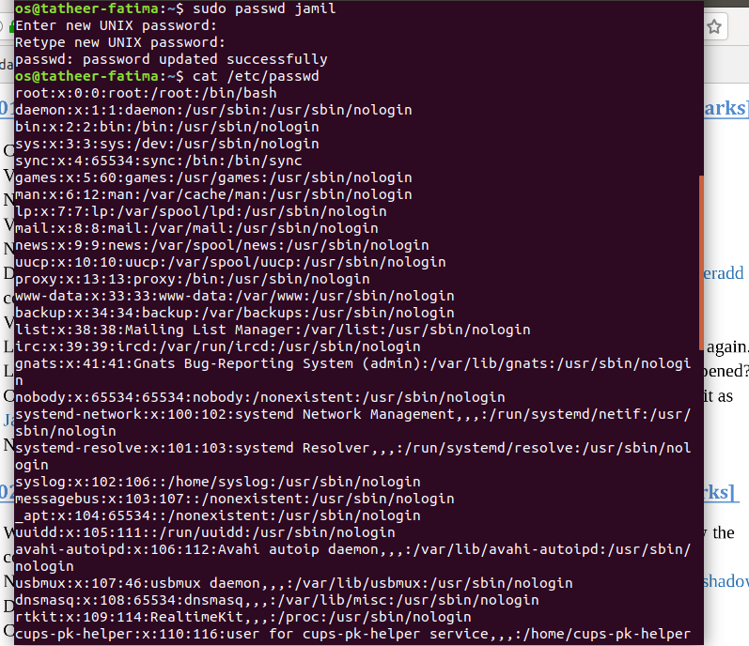

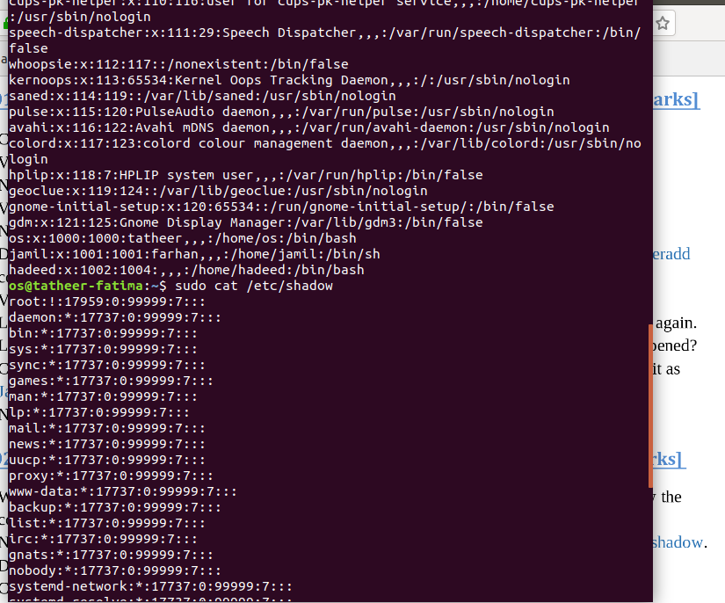

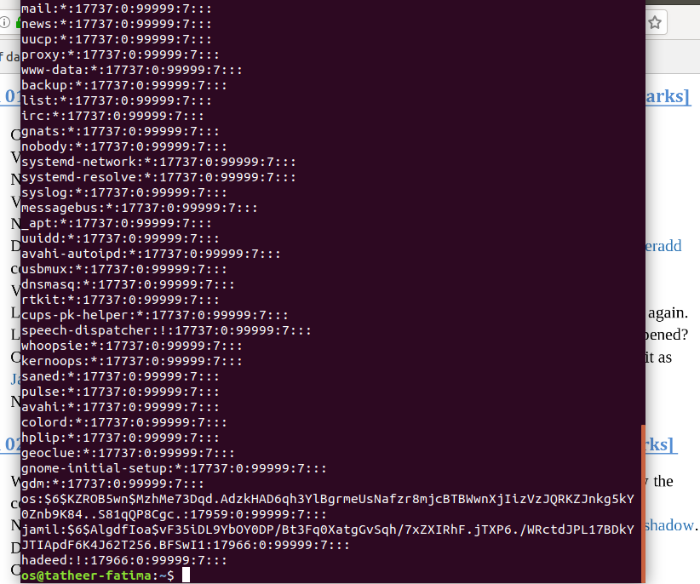
(e)

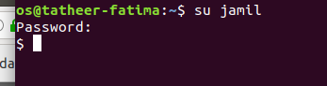

(f) nahi krna.

(g)

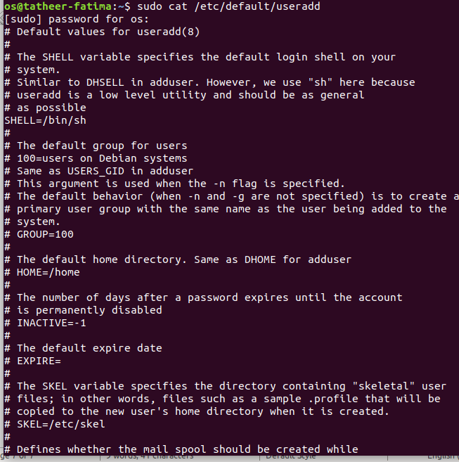

(h)

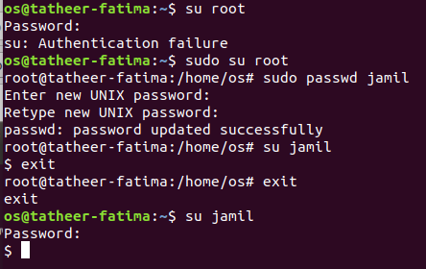

(I)

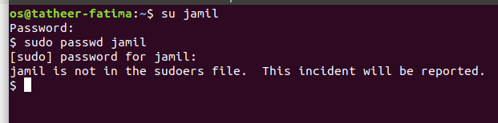

(j)

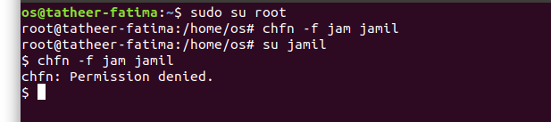

(k)

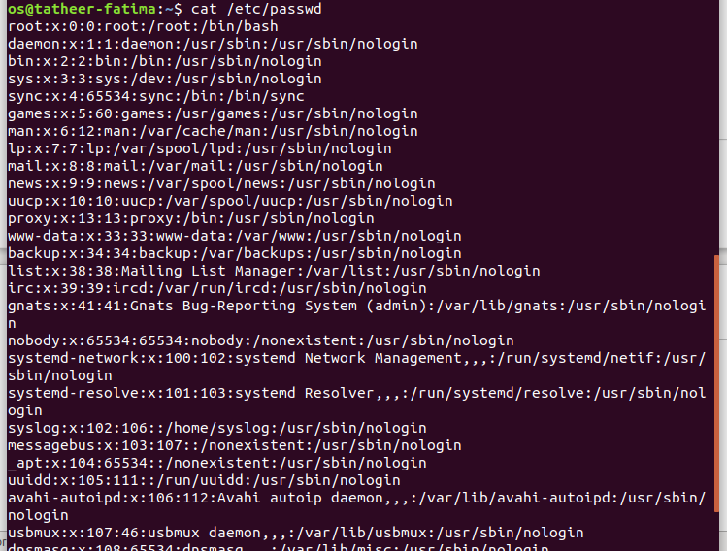
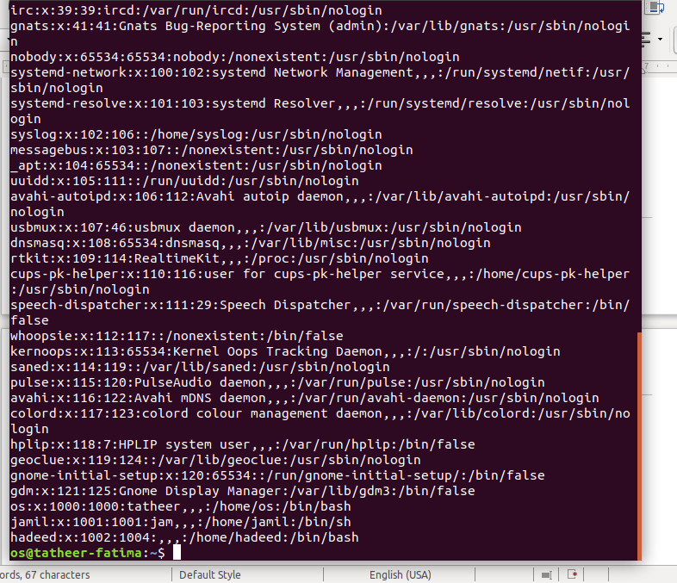

QUESTION # 2 :

(a)
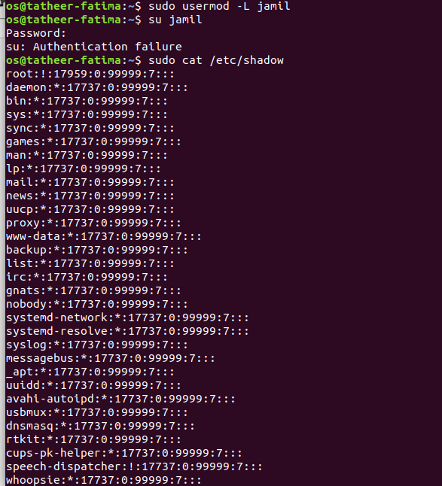
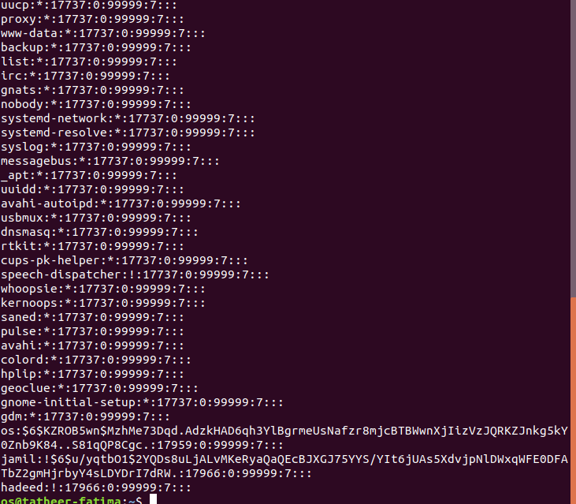

(b)

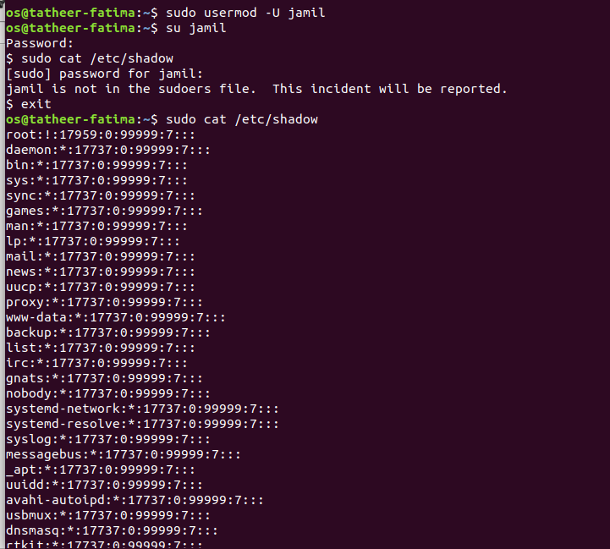
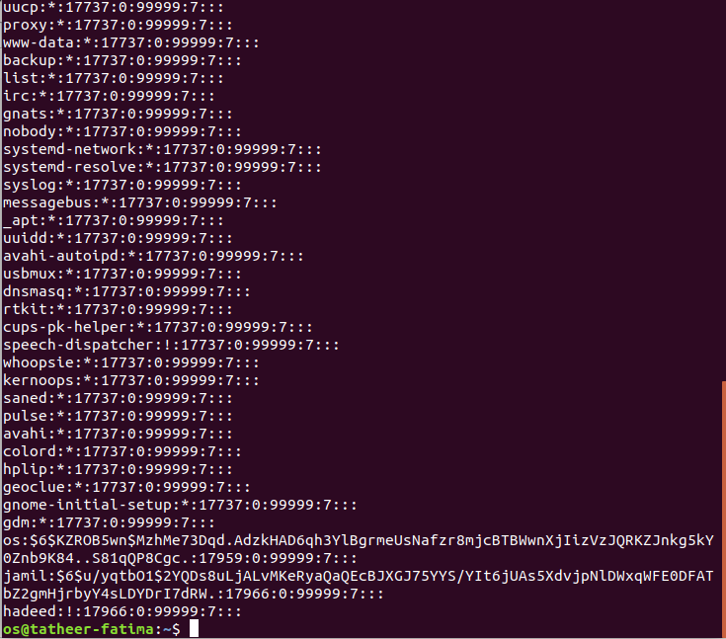

(c)

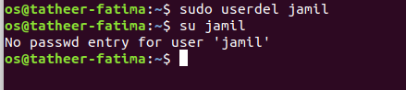

(d)
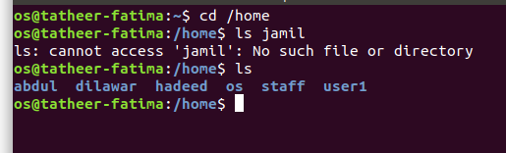
(e)

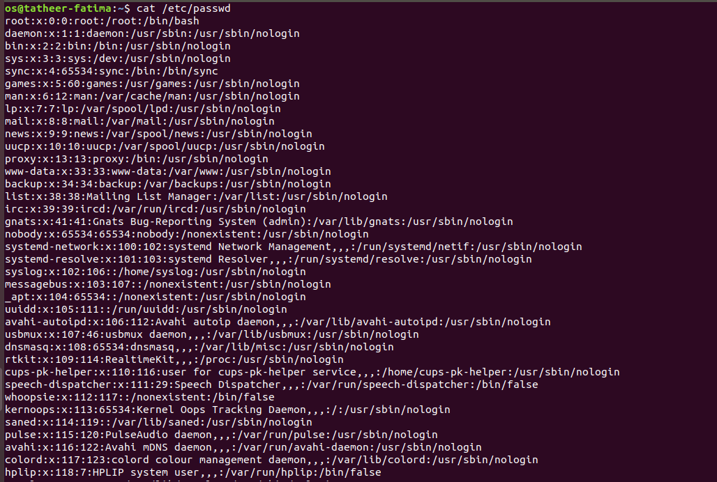

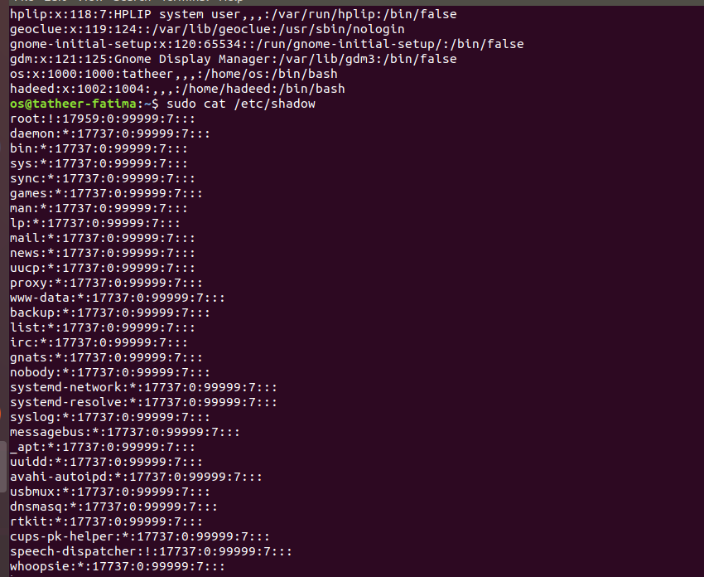
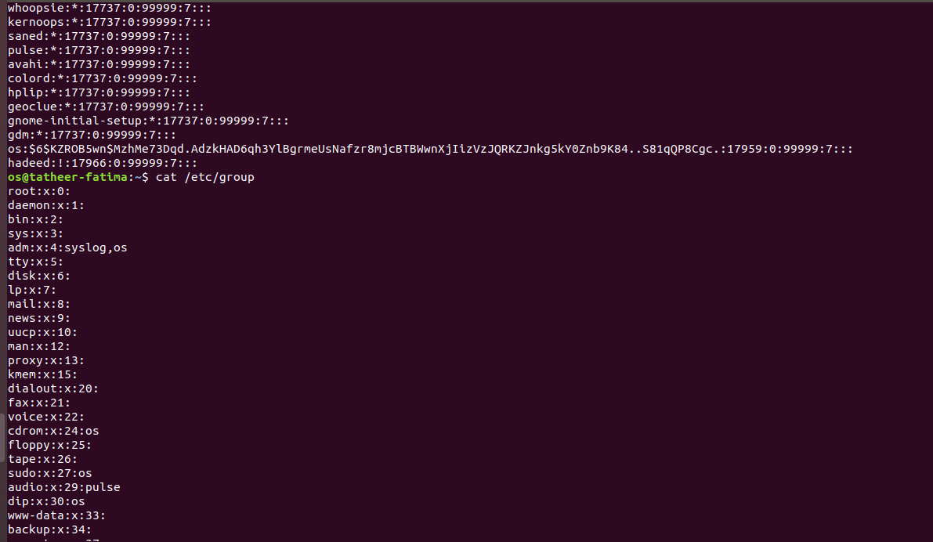

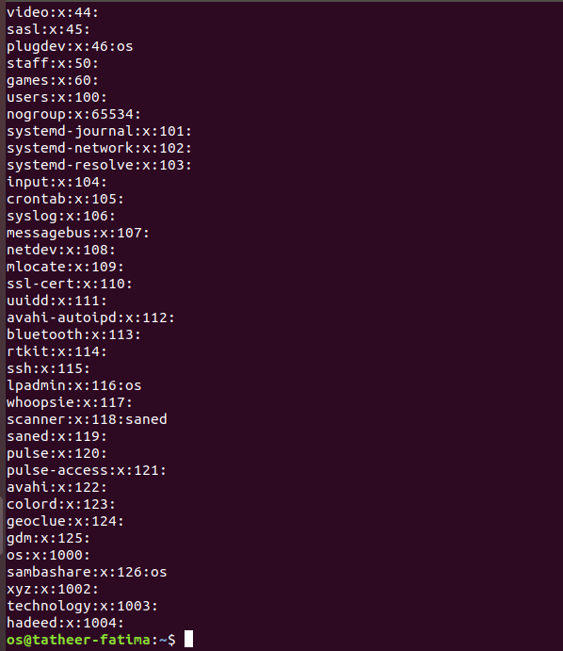

(f)(g)

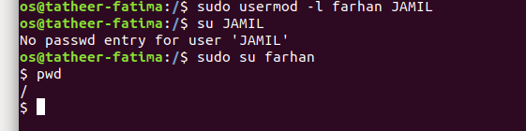

(h)
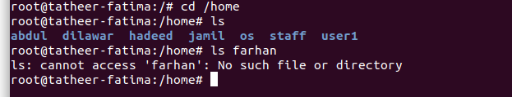

(I)
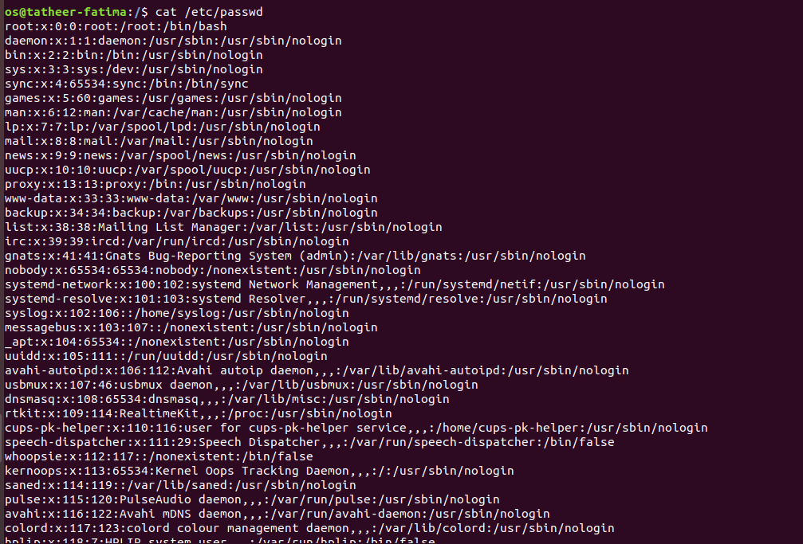
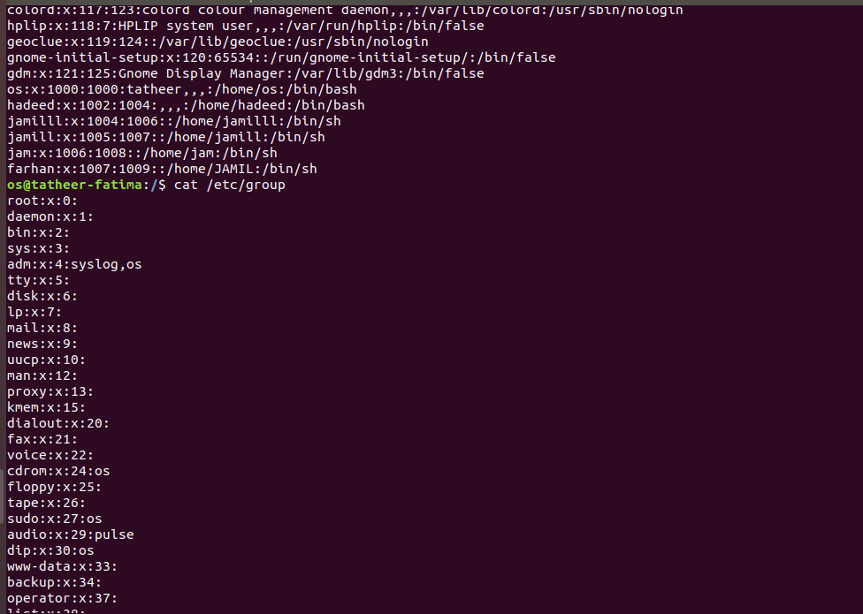

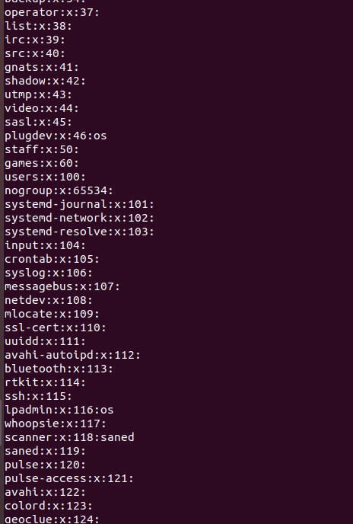

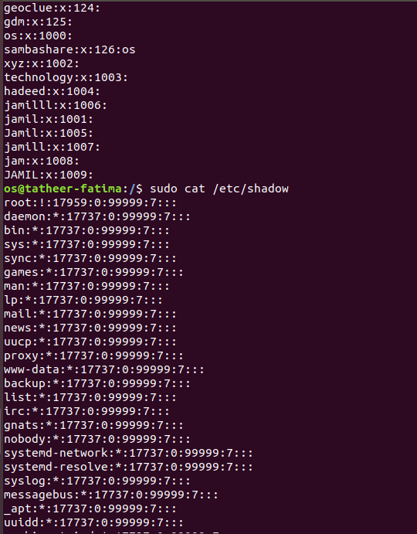

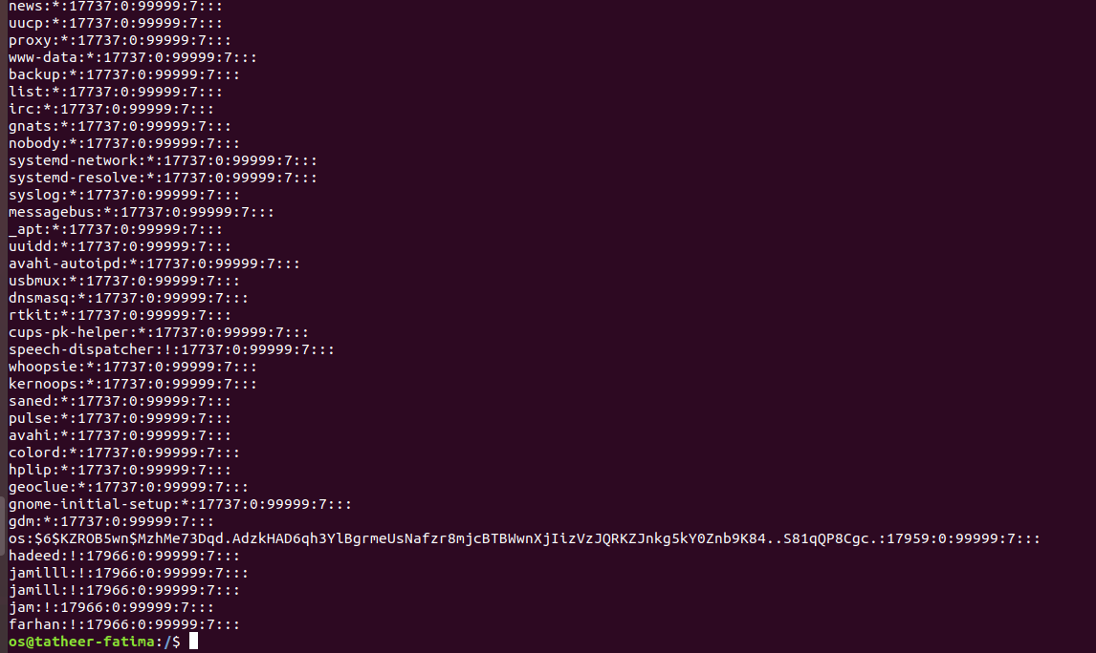

(j)

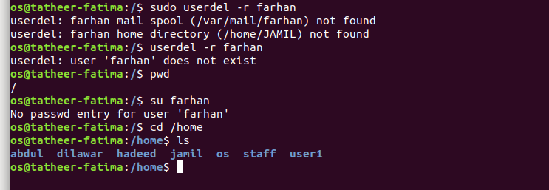

(k)

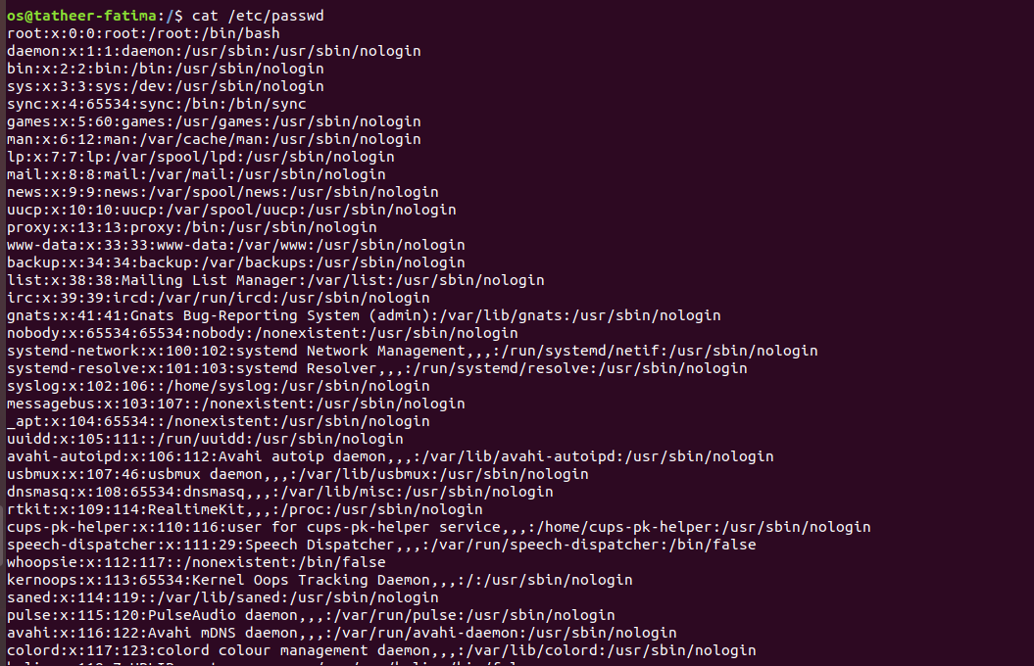

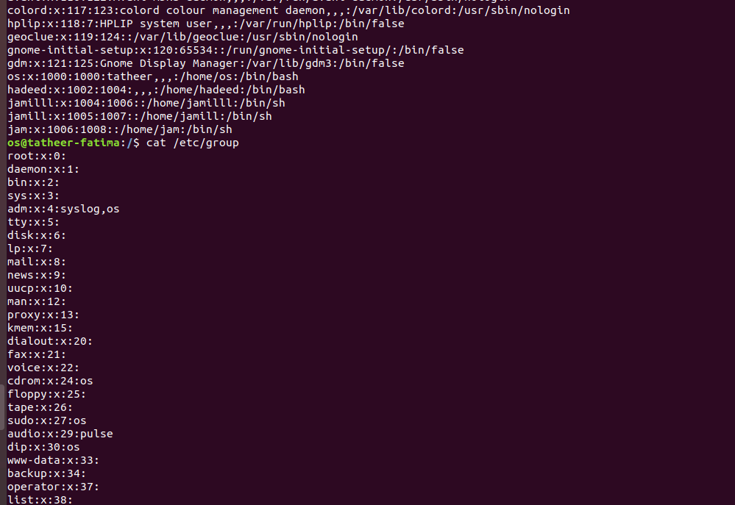

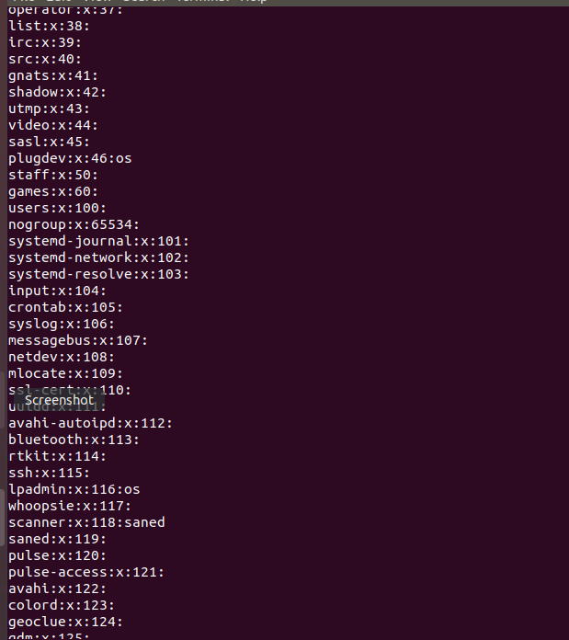

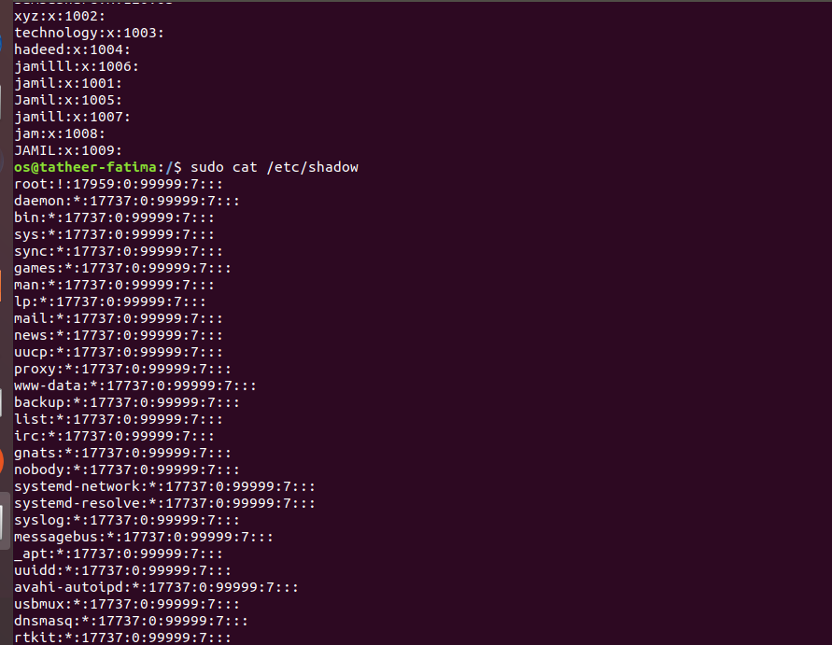

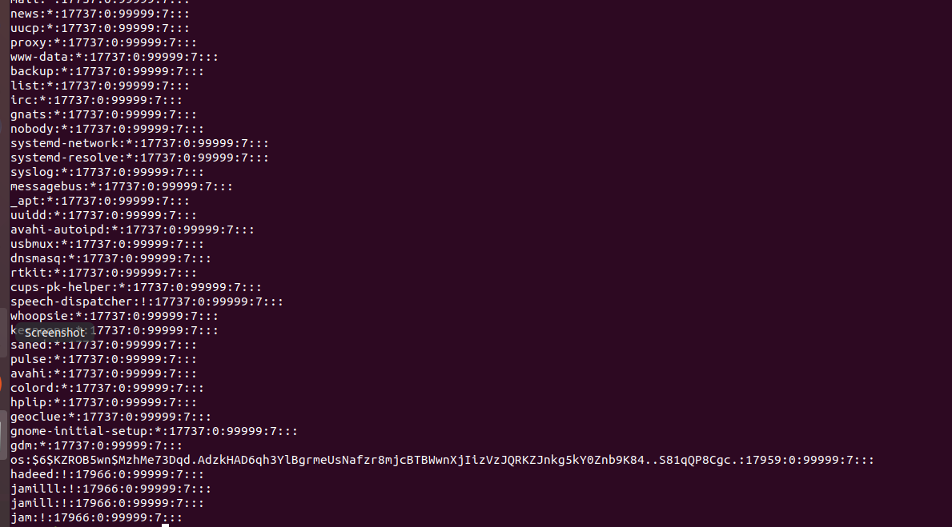

QUESTION # 3:
(a)
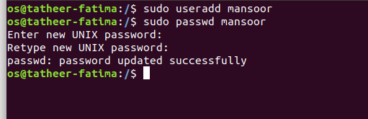

(b)

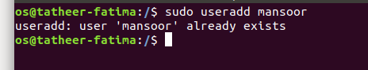

(c) achaaa…..

(d)

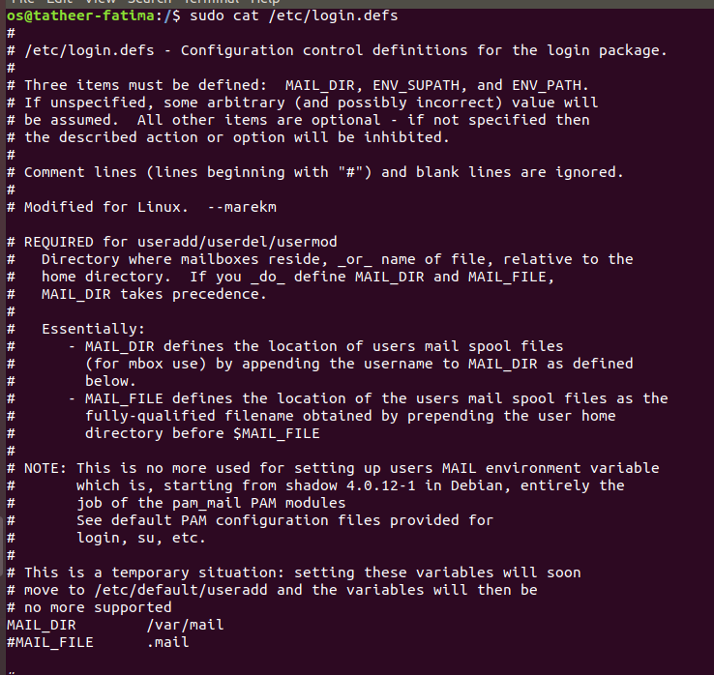

(e)

(f)

QUESTION # 4:
(a)
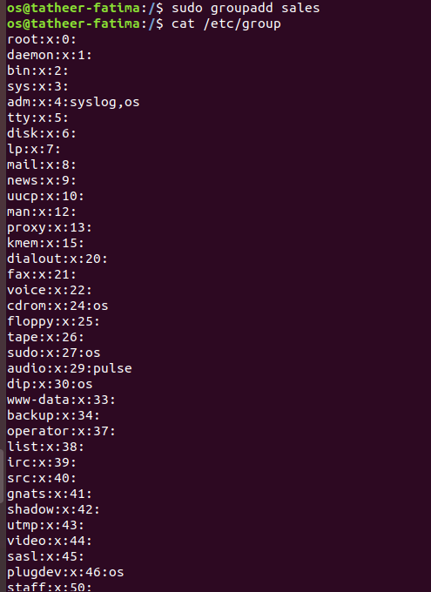

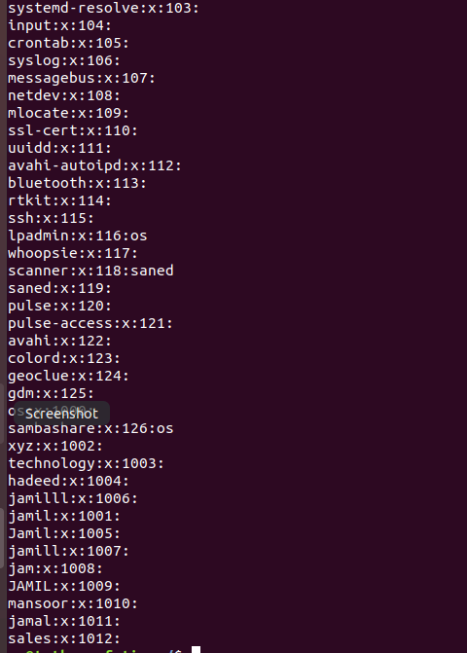

(b)
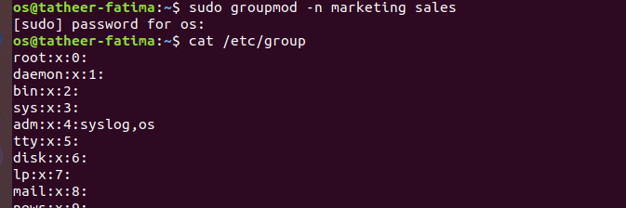
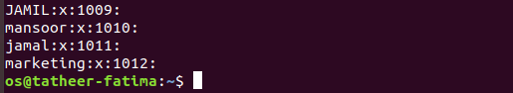

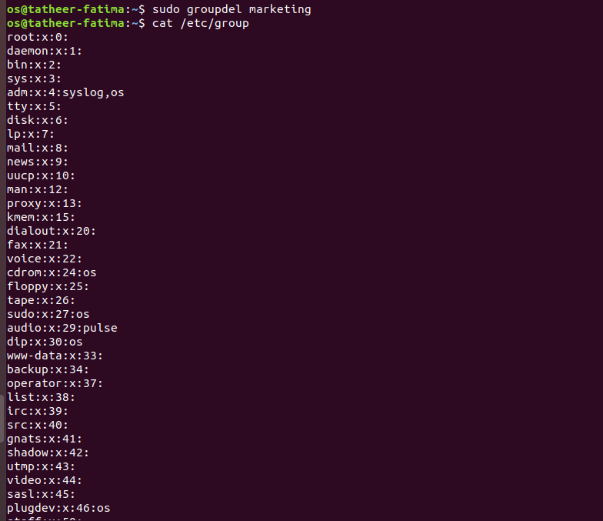
(c)

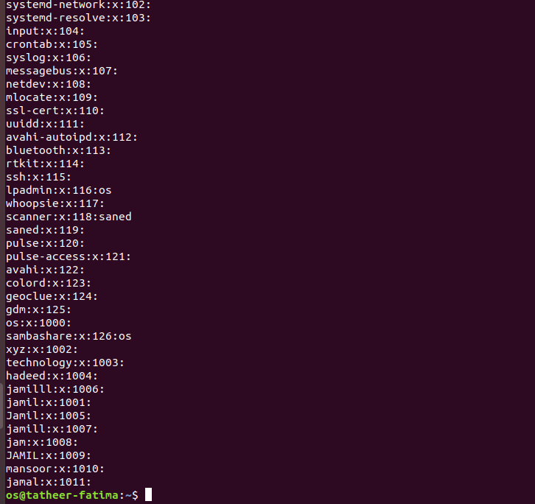

(d)

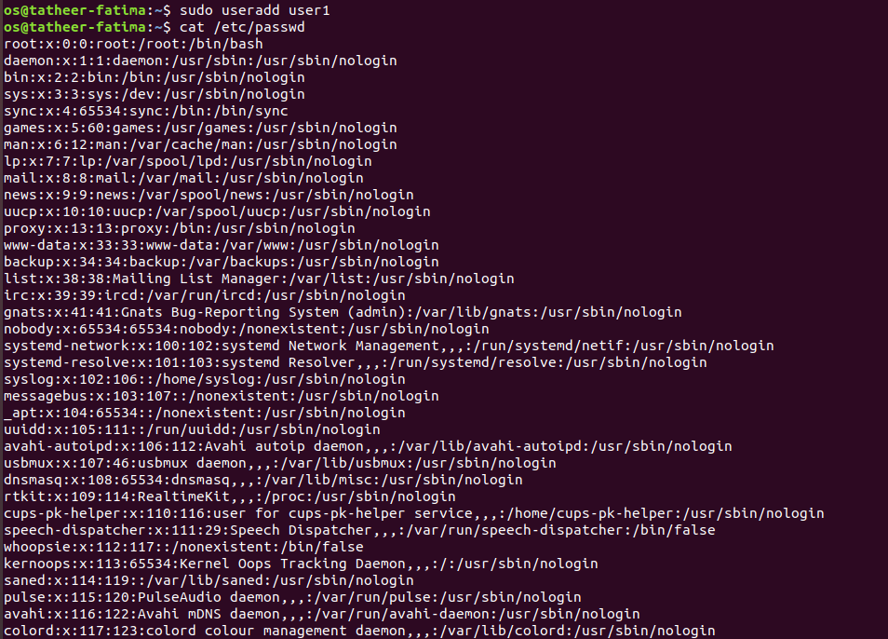

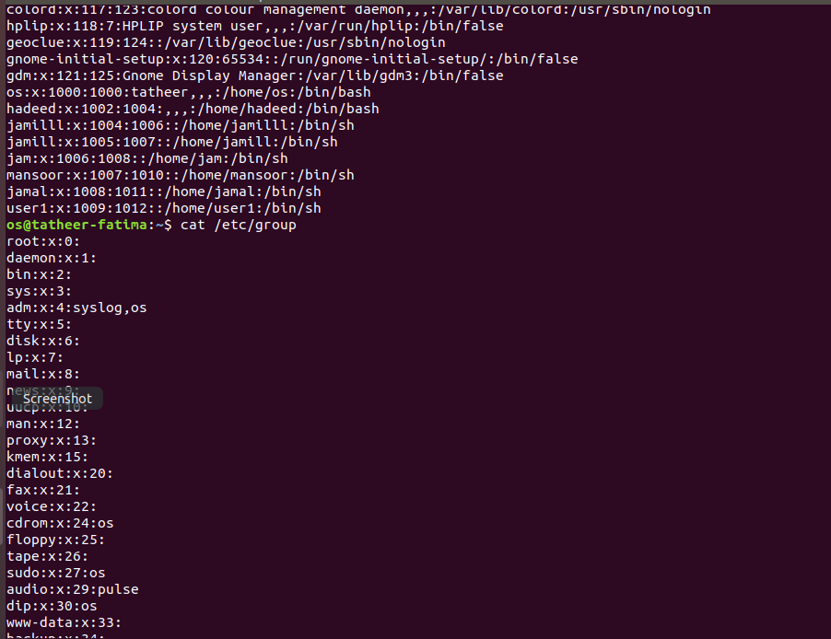

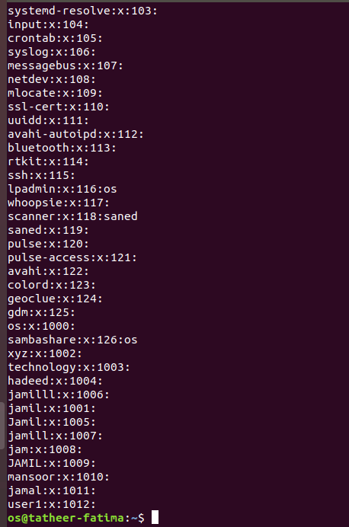

(e)

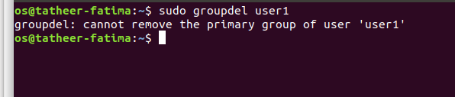
(f)

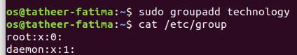

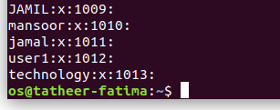

(g)

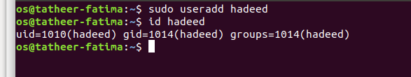

(h)

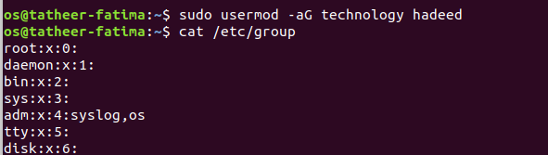
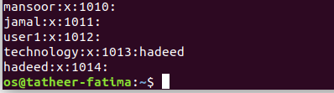

(I)
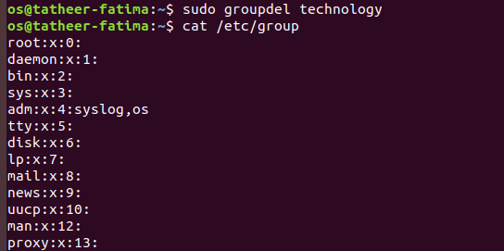

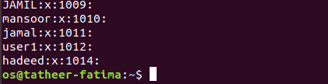

(j)
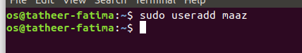

(k)
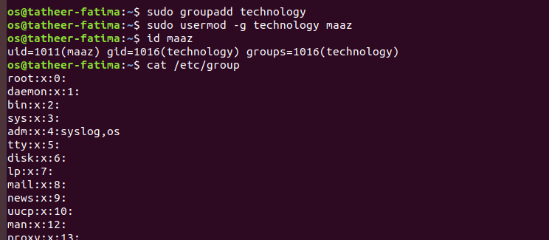

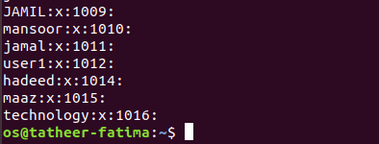

(l)
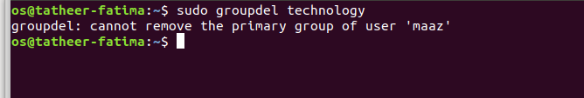
(m)
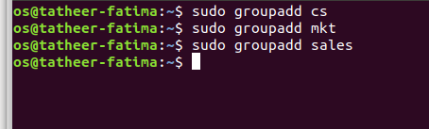

(n)
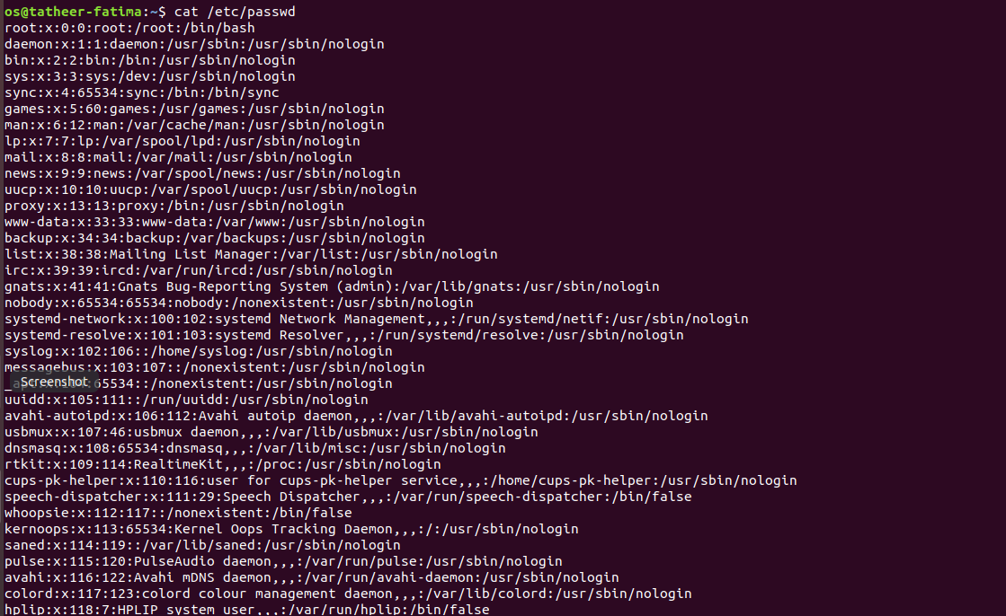

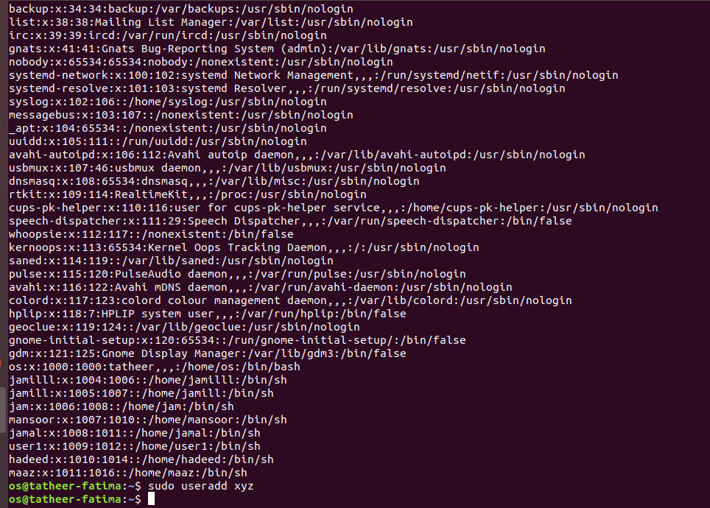

(o)
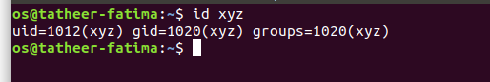

(p)
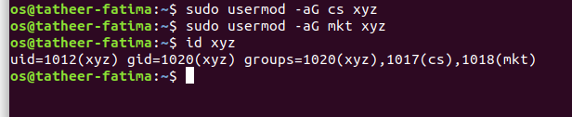
(q)

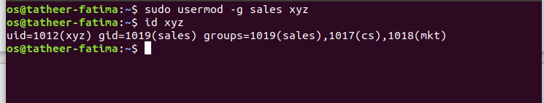

QUESTION #5:

(a)
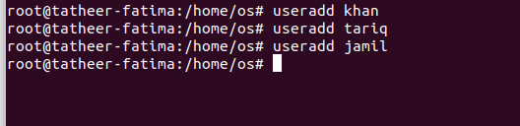

(b)
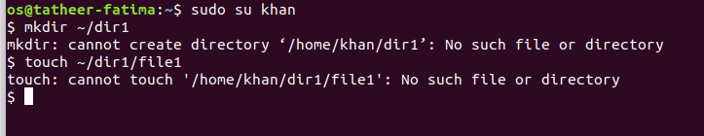
(c)
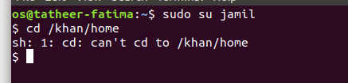

(d)

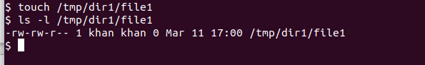
(e)
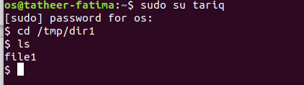

(f)
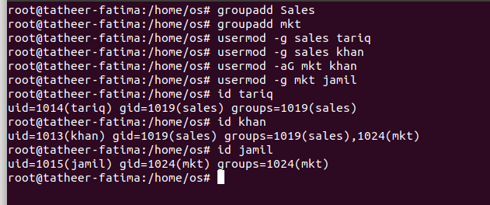

(g)

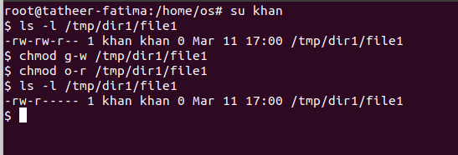

(h)

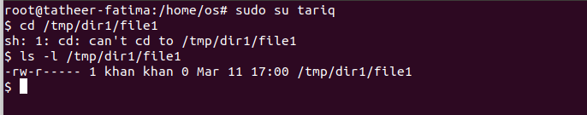
(I)
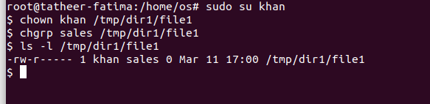

(j)
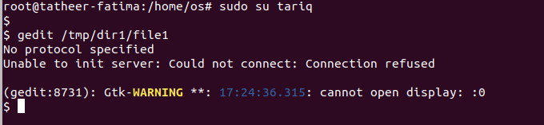
(k)

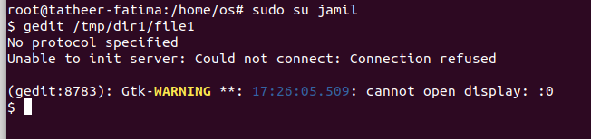
(l)
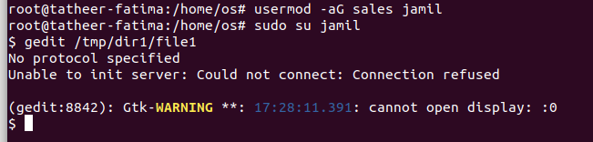

QUESTION # 6:
(a)
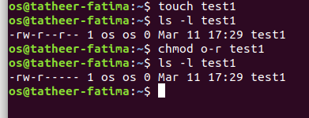

(b)
(a) Owner of courses is permitted to read write and execute, group is permitted to read only, and others are not permitted to anything.
(b) Sets permission of owner of courses to read write and execute.
(c) Sets permission of a user’s home directory as owner to all read write and execute and prohibits groups and others to do anything.
(d) Prohibits sample’s owner, groups and others from reading and writing.
(e) Prohibits sample’s owner, groups and others from reading and writing.
(f) Sets permission of sample’s owner, groups and others to execute.
(g) Assigns set of sample’s owner’s permissions to groups of sample.
(h) Prohibits sample’s groups and others to do anything.
(I) Sets permissions of lab5 in home directory as read, write and execute for owner and groups and read, write for others.
(j) Sets permissions of lab in home directory as read, write and execute for owner, read and execute for groups and execute for others.

(c)

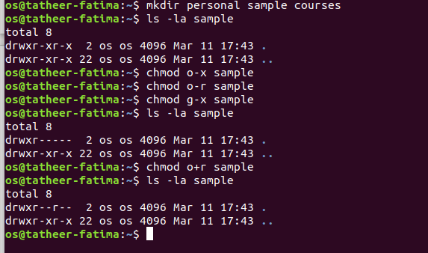
(d)
Yes, anyone can read this file because home directory has read permissions and file also has read permissions. However, everyone will not be able to write or execute it as home directory denies permission of writing and executing.

